Policy Name: Observer Policy

Policy Number: 157

Introduction
This policy sets out how The Chorley Surgery will ensure that all patients are aware that the practice hosts a number of clinical and non-clinical personnel (student nurses, doctors, paramedics, those undertaking work experience) who will be referred to as ‘observers’ herein, for whom observing clinical consultations is beneficial for their professional development and learning. It is acknowledged that this, at times, can be perceived as intrusive by the patient and in such instances the trainee/observer will be asked to leave the consultation room.

Status
The practice aims to design and implement policies and procedures that meet the diverse needs of our service and workforce, ensuring that none are placed at a disadvantage over others, in accordance with the Equality Act 2010. Consideration has been given to the impact this policy might have in regard to the individual protected characteristics of those to whom it applies.

This document and any procedures contained within it are non-contractual and may be modified or withdrawn at any time. For the avoidance of doubt, it does not form part of your contract of employment.

Training and support
The practice will provide guidance and support to help those to whom it applies understand their rights and responsibilities under this policy. Additional support will be provided to managers and supervisors to enable them to deal more effectively with matters arising from this policy.

Scope
Who it applies to
This document applies to all employees of the practice. Other individuals performing functions in relation to the practice, such as agency workers, locums and contractors, are encouraged to use it.

Why and how it applies to them
All clinical staff may at some point be asked to host an observer at The Chorley Surgery. Therefore, it is essential that clinical personnel are fully aware of their individual responsibilities when hosting such individuals, which will ensure that the patient’s privacy is respected at all times.

Definition of terms
Observer
A person who watches what happens but has no active part in it.

Voluntary consent
The decision to consent or not to consent must be made by the individual patient and must not be influenced by healthcare professionals, friends or family members.

Capacity
The person must be capable of giving consent, which means that they fully understand the information given to them and can use it to make an informed decision.

Policy
Raising patient awareness
At The Chorley Surgery the observer policy is clearly displayed in the waiting area, in all clinical areas and annotated in the practice leaflet as well as on the practice website. When a patient arrives for their appointment, where applicable, they must be notified that the clinician they are about to see has an observer with them. They are to be offered the opportunity to request that the observer is not present during the consultation at the point of booking in for their appointment. The receptionist is then to advise the clinician using the clinical messaging system.

Reaffirming the patient decision
Upon greeting the patient in the consultation room, the clinician responsible for hosting and supervising the observer is to greet the patient using the following suggested wording:

“Good morning/afternoon, [state patient name]. I have [introduce observer] with me today, who’s a [state role, e.g. student nurse]. Are you happy for them to witness the consultation today? This is completely your decision and if you’re not happy, they’ll leave the consultation room.”

If the patient agrees to allow the observer to remain, this must be clearly documented in the patient’s healthcare record.

Considerations
In a diverse multicultural society, it is important to acknowledge the spiritual, social and cultural factors associated with the patient population. Clinicians must respect the patient’s wishes and act accordingly to ensure that trust between the clinician and the patient is maintained.

Local guidance should be sought regarding patients who are suffering from mental illness or those with learning difficulties. A relative or carer will prove to be a valuable adjunct to an observer.

Confidentiality
Observers are to ensure that they adhere to the practice’s Caldicott and information governance policies. The clinician leading the consultation must reassure the patient that all observers at The Chorley Surgery fully understand their obligation to maintain confidentiality at all times.

Procedure
The procedure for observers is illustrated below in diagrammatic form.
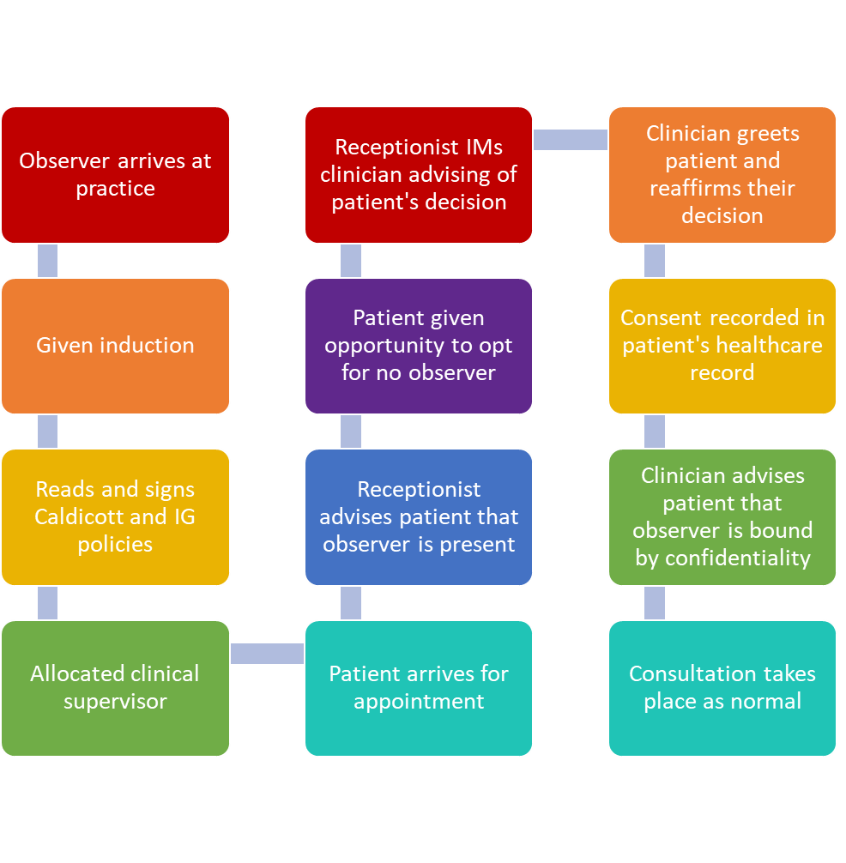

Waiting room information
A poster for the waiting room and clinical consultation rooms regarding observers can be found at Annex A.

Summary
It is essential that all patients are aware that The Chorley Surgery, from time to time, will host observers. They must also be informed that an observer will only be present if they give voluntary consent; if they opt not to do so, an observer will not be present during the clinical consultation. Effective communication and adherence to this policy will reduce confusion and ensure that patients continue to be content with the level of service provided.

Annex A – Observer poster
Observers during consultations

The Chorley Surgery will have present in the practice clinical and non-clinical personnel (student nurses, doctors, paramedics, work experience students) who we refer to as ‘observers’.
As part of their professional development and learning, they need to witness clinical consultations. Our observers are completing an important phase of their training and your support will help them to achieve their learning objectives.
You will be told if your clinician has an observer present and asked if you are happy for them to remain during the consultation.
Don’t worry; if you are not happy, they will leave before your clinician begins the consultation as we want you to feel as comfortable as possible during the consultation.

