Policy Name: Duty of Candour

Policy Number: 36 v2.0

Policy statement
The Chorley Surgery will fulfil its obligations to satisfy its duty of candour.

The CQC document titled Learning, candour and accountability states that all health and social care providers, including NHS trusts, are required to be “open and transparent with the people who use their services when there are notifiable safety incidents. This means incidents that are categorised as death, moderate harm, severe harm or prolonged psychological harm.”

This is a statutory requirement under Regulation 20 of the Health and Social Care Act 2008 (Regulated Activities) Regulations 2014.

This policy sets out the way in which The Chorley Surgery will comply with its obligations and what individuals’ responsibilities are in relation to raising any concerns that they have and how those concerns will be dealt with.

The intention is that there is a culture of openness and honesty to improve the safety of patients, staff and visitors to The Chorley Surgery as well as raising the quality of healthcare systems. If patients or employees have suffered harm as a result of using our services, the practice will investigate, assess and, if necessary, apologise for and explain what has happened.

It is also intended to improve the levels of care, responsibility and communication between healthcare organisations and patients and/or their carers, staff and visitors and make sure that openness, honesty and timeliness underpin our responses to such incidents.

Status
The Chorley Surgery aims to design and implement policies and procedures that meet the diverse needs of our service and workforce, ensuring that none are placed at a disadvantage over others, in accordance with the Equality Act 2010. Consideration has been given to the impact this policy might have with regard to the individual protected characteristics of those to whom it applies.

This document and any procedures contained within it are non-contractual and may be modified or withdrawn at any time. For the avoidance of doubt, it does not form part of your contract of employment.

Duty of candour
The duty of candour is a general duty to be open and transparent with people receiving care from The Chorley Surgery.
Both the statutory duty of candour and professional duty of candour have similar aims. These are to make sure that those providing care are open and transparent with the people using their services whether or not something has gone wrong.

In interpreting the regulation on the duty of candour, the CQC uses the definitions of openness, transparency and candour used in the Sir Robert Francis QC report into the public enquiry of the Mid Staffordshire NHS Foundation Trust.

Openness
Openness – enabling concerns and complaints to be raised freely without fear and questions asked to be answered.

Transparency
Transparency – allowing information about the truth about performance and outcomes to be shared with staff, patients, the public and regulators.

Candour
Candour – any patient harmed by the provision of a healthcare service is informed of the fact and an appropriate remedy offered, regardless of whether a complaint has been made or a question asked about it.

Patient safety
The NHS England definition of patient safety is:

“Patient safety is the avoidance of unintended or unexpected harm to people during the provision of healthcare. We support providers to minimise patient safety incidents and drive improvements in safety and quality. Patients should be treated in a safe environment and protected from avoidable harm”.

Event reporting
The NHS Learning from Patient Safety Events (LFPSE) Service was established in July 2021 and will ultimately replace the NHS National Reporting and Learning System (NRLS). In the interim period, NRLS remains the central database of patient safety incident reports.

Further information on the LFPSE can be sought here. Additionally, NRLS reporting can be found here. This includes all of the latest developments from LFPSE.

Degrees of harm
The degrees of harm are common to all services providers and aligned to the CQC’s notification system for reporting deaths and serious injuries and are shown in the table below.
Moderate harm | Harm that requires a moderate increase in treatment and significant, but not permanent, harm.
Severe harm | A permanent lessening of bodily, sensory, motor, physiologic or intellectual functions, including removal of the wrong limb or organ or brain damage, that is related directly to the incident and not related to the natural course of the service user's illness or underlying condition.
Moderate increase in treatment | An unplanned return to surgery, an unplanned re-admission, a prolonged episode of care, extra time in hospital or as an outpatient, cancelling of treatment, or transfer to another treatment area (such as intensive care)
Prolonged pain | Pain which a service user has experienced, or is likely to experience, for a continuous period of at least 28 days.
Prolonged psychological harm | Psychological harm which a service user has experienced, or is likely to experience, for a continuous period of at least 28 days.

Notifiable safety incidents
Notifiable safety incident is a specific term defined in the duty of candour regulation. It should not be confused with other types of safety incidents or notifications. A notifiable safety incident must meet all three of the following criteria:
- It must have been unintended or unexpected
- It must have occurred during the provision of regulated activity
- In the reasonable opinion of a healthcare professional, it already has, or might, result in death, or severe or moderate harm to the person receiving care

If any of these criteria are not met, it is not a notifiable safety incident (but remember that the overarching duty of candour, to be open and transparent, always applies).
The flow diagram below illustrates how to identify a notifiable safety incident.
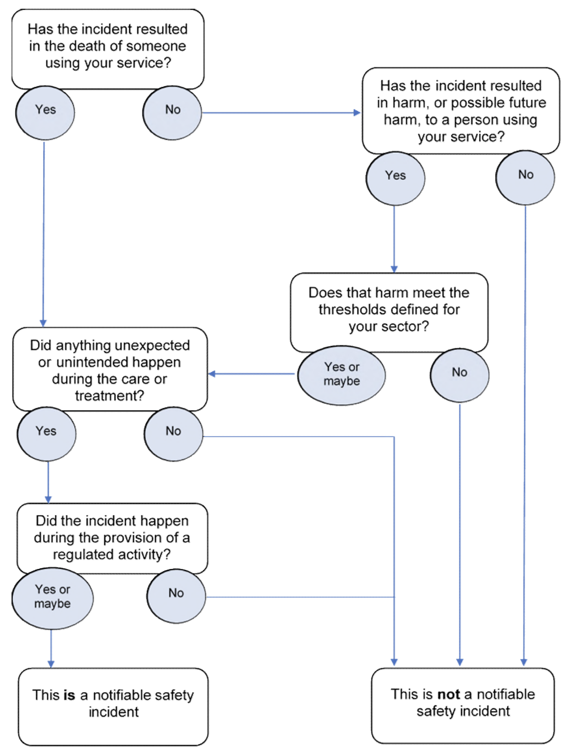

Responding to a notifiable safety incident
The diagram below illustrates the process to be followed when a notifiable safety incident has been identified:

It is essential that The Chorley Surgery keeps a written record of all communication with the service user.

A ‘sincere apology’
The Francis Inquiry Report indicated the importance of affected parties receiving a sincere apology for the impact that any incident can have on the patient, their families, next of kin and their carers especially in incidents that cause severe harm or the loss of life.

A meaningful apology for the incident or the circumstances that have led to the incident is an important part of coping with the effect that it has caused and will demonstrate that The Chorley Surgery has taken events seriously, be they major or minor.

An apology under the duty of candour does not constitute an admission of liability. Patients and relatives are to be offered detailed explanations of what led to the incident(s) occurring and their outcomes as well as a sincere apology and acknowledgement of the impact it has had on them. This helps them to understand that there are lessons that the practice can learn to ensure this does not happen again in the future.

CQC have provided guidance for providers that states that saying sorry is not admitting fault, nor any admission of liability, but it is a crucial part of our duty of candour.

To fulfil the duty of candour, The Chorley Surgery will apologise for the harm caused, regardless of fault, as well as being open and transparent about what has happened.

Required actions and timeframes under the duty of candour

Requirement under duty of candour | Timeframe
Patient or their family/carer informed that an incident has occurred (moderate harm, severe harm or death) | Maximum 10 working days from incident being reported
An oral notification of the incident (preferably face-to-face where possible) unless patient or their family/carer decline notification or cannot be contacted in person  A sincere expression of apology must be provided verbally as part of this notification | Maximum 10 working days from incident being reported
Offer of a written notification to be made.  This must include a written sincere apology. | Maximum 10 working days from incident being reported  A record of this offer and apology must be made (regardless if it has been accepted or not)
Step-by-step explanation of the facts (in plain English) must be offered | As soon as practicable  This can be an initial view, pending investigation, and stated as such to the receiver of the explanation
Maintain full written documentation of any meetings | No timeframe  If meetings are offered but declined this must be recorded
Any new information that has arisen (whether during or after investigation) must be offered | As soon as practicable
Share any incident investigation report (including action plans) in the approved format (plain English) | Within 10 working days of report being signed off as complete and closed
Copies of any information shared with the patient to the commissioner upon request | As necessary

Requirements related to meeting CQC Regulation 20
Once a notifiable safety incident has been identified, the service provider must:¹

- Act in an open and transparent way with the relevant persons in relation to the care and treatment provided to people who use services in carrying on a regulated activity
- Tell the relevant person as soon as reasonably practicable after becoming aware that a safety incident has occurred and provide support to them in relation to the incident, including when giving the notification
- Provide an account of the incident which, to the best of the organisation’s knowledge, is true of all the facts the organisation knows about the incident as at the date of the notification
- Advise the relevant person what further enquiries the organisation believes are appropriate
- Offer an apology
- Follow up by giving the same information in writing and provide an update on the enquiries. A sample follow-up letter following a face-to-face notification of a patient safety incident under the duty of candour is shown at Annex A
- Keep a written record of all communication with the relevant person

Reporting an incident to the authorities
Depending on the degree of harm as outlined above, The Chorley Surgery must consider reporting the incident to the following:
- Integrated Care Board
- Care Quality Commission
- Learning from Patient Safety Events Service

Summary
By following the procedures required under a duty of candour as outlined in this policy, The Chorley Surgery will ensure that it meets the requirements expected of it not only by the CQC but by its patients.

In addition, all employees and partners are also reminded that any matter raised under this procedure will be investigated thoroughly, promptly and confidentially and, in most circumstances, any outcome of the investigation will be made known to all staff.

Annex A: Information to support a sample letter

The sample text shown below may be used in a letter following a notification being given in person to a patient (relevant person) and/or their relative of a patient safety incident/event.
This is in accordance with the organisation’s obligations under the duty of candour. See below the relevant components of Regulation 20.
- Component 20 (2)

When a notifiable safety incident has occurred, the relevant person must be informed in person as soon as reasonably practicable after the incident has been identified.
For NHS contract holders, there is a requirement for the notification to be made in person within 10 working days of the incident being reported.
- Component 20(4)

A written notification must be given or sent following the initial meeting even though the enquiries may not yet be complete. This written notification must contain:
- All the relevant information that was provided in person at the initial notification meeting

- An apology

- The results of any enquiry made since the initial notification meeting was given in person

- The outcomes or results of any further enquiries and investigations must also be provided in writing to the relevant person through further written notifications if they wish to receive these

- Component 20(5)

If the relevant person cannot be contacted in person or declines to speak to the representative of the relevant person, a written record is to be kept of attempts to contact or speak to the relevant person.

The provider must make every reasonable attempt to contact the relevant person through all available means of communication.
- Component 20(6)

The registered provider must keep a copy of all correspondence with the relevant person under component 20(4).
If in any doubt, seek advice from [medical protection organisation and contact number] with regard to the content of the letter and how in-depth this should be.

Annex B: Sample letter

[Insert patient’s or carer’s name and address along with the date and reference number of the letter as per the organisation’s house style].

Dear (patient/relative)
Following our initial meeting which took place on [insert date] to inform you of a notifiable safety incident under the statutory duty of candour, I am writing to provide you/your [identify relationship, e.g., husband, wife, etc.] with all the relevant information that was provided at that initial face-to-face meeting.
As explained at the initial face-to-face meeting, we investigated this event and explained our findings to you as follows [insert details of findings].
*Delete if not applicable
[As explained at the initial meeting, we stated that we are undertaking further enquiries and when these have been completed, we will inform you of the outcome.]
OR
[As explained at our initial meeting, we stated that were undertaking further enquiries and these have been completed and the outcome of these are as follows.]
Please find enclosed a leaflet detailing the duty of candour. This has been created by an organisation called AvMA and has been endorsed by the Care Quality Commission.
https://www.avma.org.uk/policy-campaigns/duty-of-candour/duty-of-candour-leaflet/
We would like to express our sincere apologies that this event has occurred as the organisation aims to provide the good, high-quality services that our patients expect.
Yours sincerely,

For and on behalf of the organisation

NHS England Patient Safety
CQC Regulation 20: Duty of candour

