# Policy Name: Home Visit Policy

## Policy Number: 101

# Introduction

Home Visits are reserved for the following groups of patients:

* **Terminally ill;**
* **Housebound** (Confined to one room of house by nature of illness often with carers attending numerous times throughout the day)**;**
* **Patients who are severely ill and cannot be mobilised.**
* **Patients who sadly die at Home and Death needs to be Certified.**

**Background**

Although a traditional part of general practice, home visits are time consuming. Please remember that several patients can be seen in the practice in the time that it takes to make one home visit. So please help us to help you and our other patients by visiting the surgery whenever possible.

**Access**

We want to see patients as quickly as possible, and the best way is often to encourage them to come to the surgery, because your GP will have **access to all your medical records**, including those held on computer. There are also **better facilities** for examining and treating patients at the surgery. **Consultations outside of the surgery carry a higher risk of medical errors.**

Babies and small children should be brought to the surgery where we will do our best to see them promptly. **If the Reception staff are made aware that your child is particularly unwell, they will do everything they can to see that you are not kept waiting unnecessarily to see the doctor**.

Transport/social problems – **We cannot undertake home visits for reasons of convenience or lack of transport**. We will be happy to provide you with details of local taxi firms. From experience, we are aware that relatives, neighbors or friends are often willing to help out. Our responsibility to you is to resolve the medical problem you have; your responsibility is to take all the reasonable steps you are able to, to enable us to do that.

Please request visits before **11am** whenever possible as this allows the Doctor to plan their day accordingly. Late requests often lead to disruption of the appointment system and excessive waiting times for others.

**V-Request Via Care Home**

**What do GP surgeries do when they receive a vrequest.org home visit request?**

Below is a flow chart of how the V-Request comes into surgery and the process in which it is dealt with.

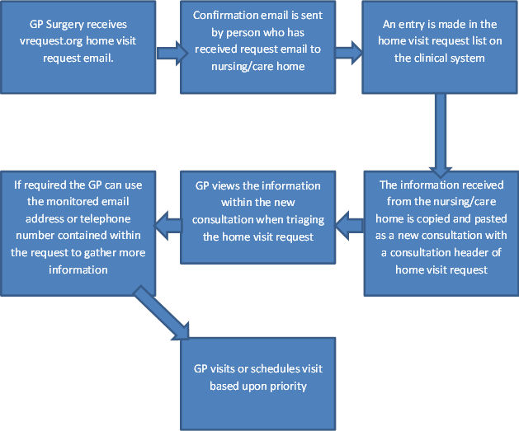

**Triage**

**A doctor/nurse will call you back on most occasions to assess your problem. This is to enable the doctor to prioritise visits**.

It may be that your problem can be dealt with by telephone advice, or that it would be more appropriate to send an Advanced Nurse Practitioner or a First Contact Practitioner or indeed arrange a hospital attendance. It also prepares the doctor to collect some information required as necessary for the visit.

He/she may ask you to come to the surgery, where you will be seen as soon as possible.

**Please note**

The doctors would like to stress that **NO patient in definite need of a home visit will be refused.**

In the past, GPs were able to do routine follow up home visits. Sadly, pressures of time and more patients needing attention means this is usually no longer possible.

**Some problems such as severe chest pains or shortness of breath are medical emergencies and you will be advised to dial 999.**