Policy Name: Violence & Aggression Policy

(zero tolerance)

Policy Number: 59 v1.6

Introduction
The NHS has a zero-tolerance policy of all violence and aggression. This policy is for the protection of all NHS staff, but also for the protection of other patients, their families, visitors, etc. To ensure that this zero-tolerance approach is adhered to, it is essential to have robust policies and procedures in place. In General Practice, this will need to cover a variety of situations in which incidents could occur. Most patients behave in acceptable or manageable ways, however the incidence of excessively aggressive or violent attacks in the GP practice is increasing.

The Chorley Surgery recognises that there can be contributory reasons for patients behaving in difficult or challenging ways, however, where this tips over into aggression or violence; the practice will adopt a zero-tolerance approach.

The Chorley Surgery aims to provide high quality healthcare and we will treat all patients with respect and dignity. In return we expect all our staff to be treated with respect. We will not tolerate abusive language or threatening behaviour against any member of staff. Such behaviour may result in the offender being denied access to the doctor and/or further measures as appropriate.

This policy applies throughout the premises, including any car park and grounds. It also applies to any employee or partner away from the practice but only in so far as it relates to the business of the practice.

Communication
The Chorley Surgery will communicate this policy by a variety of communication mediums e.g. a clear policy on the web site, the practice newsletter, the policy (sign) clearly displayed in the waiting area and the reception desk.

2.0 Aims and Objectives
The aims and objectives of this policy are as follows:
- To ensure adequate processes are in place for the protection of staff and patients
- To ensure staff are fully aware of their responsibilities when dealing with violent or aggressive patients
- To ensure that staff are fully aware of their rights when they must deal with such incidents

Responsibilities

Employee Responsibilities
- Employees have the responsibility to ensure their own safety and that of their colleagues at work. It is essential, therefore, that all employees are familiar with practice policies and procedures, equipment and precautions adopted to combat the risk of physical and verbal abuse.
- Familiarise themselves with practice policies and procedures, guidelines, and instructions.
- Use any equipment or devices provided for ‘at risk’ situations i.e. alarms.
- Participate in relevant training made available by the practice.
- Report all incidents of physical and verbal abuse (threatened or actual).
- Record details of incidents in compliance with practice procedures.
- Contribute towards reviews by nominated managers concerning any incidents in which they have been involved.
- Suggest precautionary measures involving changes in the layout of the work environment that can reduce risk.
- Make use of any available staff support and counselling through the practice.
- Advise the business manager/operational manager of any perceived risks involved in work activities.

The Chorley Surgery Responsibilities
- Carry out risk assessments to assess and review the duties of employees, identifying any ‘at risk’ situations and taking appropriate steps to reduce or remove the risk to employees.
- Assess and review the layout of premises to reduce the risk to employees.
- Assess and review the provision of personal safety equipment i.e. alarms.
- Develop practice policies, procedures, and guidelines for dealing with physical and verbal abuse.
- Provide support and counselling for victims or refer to suitably qualified health professionals.
- Make employees aware of risks and ensure employee involvement in suitable training courses.
- Record any incidents and take any remedial action to ensure similar incidents are prevented.

Definition
Violence and aggression are defined as:
- Violence is the use of force against a person and has the same definition as “assault” in law (i.e. an attempt, offer or application of force against the person). This would cover any person unlawfully touching any other person forcefully, spitting at another person, raising fists or feet, or verbally threatening to strike or otherwise apply force to any person.
- Aggression is regarded as threatening or abusive language or gestures, sexual gestures or behaviour, derogatory sexual or racial remarks, shouting at any person or applying force to any practice property or the personal property of any person on the practice. This would cover people banging on desks or counters or shouting in an intimidating manner.

Dealing with an Aggressive Patient
Patients can become aggressive for a variety of reasons, and it is always advisable to try to calm down the situation as early as possible, as this may prevent an incident. Being observant of patients/relatives is often the first sign that a difficult/tense situation is imminent.

Recognising the signs of an impending aggressive incident. The use of appropriate inter-personal skills in potentially difficult situations is essential. Observation of the patient/client can help in predicting when aggression may occur. The following are some of the signs to look for:
- Staring, unblinking, uncomfortable gaze.
- Muscles tensed; jawline tensed.
- Facial expression
- Person balanced to move quickly
- Fingers or eyelids twitching
- Pacing about, uncomfortable stance, alternate sitting/standing
- Withdrawn on approach
- Voice-change of pitch or tone, use of insults, obscenities, or threats
- Sweating
- Increase in rate of breathing
- Tears (crying)

Proactively diffusing a situation
- Adopt an empathic, understanding approach, and attempt to show some affinity with the other person’s position – “I can see why you are upset about that”
- Use active NLP (neuro linguistic programming) – saying a small portion of a sentence back to the patient in the patient’s own words
- Avoid confrontation, do not argue but do not agree to reward their bad behavior
- Speak and stand calmly with an open posture, but always remain balanced and ready to move away
- Do not move closer to the patient, even if they are speaking in whispers
- Try to distract the person from the immediate cause of concern by changing the course of the conversation – buy time to think, to plan, to obtain assistance – if possible ask the patient to have a seat “while I go to see what I can do to help you” – this buys time and allows you to think of your options.
- Speak clearly, evenly, and slowly and do not necessarily stop talking because the other person does not answer
- Even if the other person is very loud, do not raise your voice
- Try to identify the source (nub of their problem) of concern, acknowledge this and offer to help if possible
- Do not disagree where it is not necessary
- Do not give orders or use status or authority as a threat, remember your body language
- Never make promises which cannot be kept
- Never reward aggressive behaviour
- Do not make threats
- Be alert and send for assistance where necessary
- Be prepared to leave the situation if necessary, to avoid injury

If the incident escalates further
If the aggressor continues or becomes more verbally aggressive, then the following process should be followed:
- In the first instance a member of the staff should ask the perpetrator to stop behaving in an unacceptable way. Staff should not in any circumstances respond in a like manner.
- Should the person not stop their behaviour the Operational or Office Manager should be asked to attend, and the member of staff should explain calmly what has taken place, preferably within hearing of the perpetrator.
- If the person is acting in an unlawful manner, causes damage or strikes another then the police should be called immediately.
- Should it prove necessary to remove the person from the practice then the police should be called, and staff should not, except in the most extreme occasions, attempt to manhandle the person from the premises.
- If such a course of action proves necessary then those members of staff involved must complete a written note of the incident, detailing in chronological order what has taken place and the exact words used prior to leaving the building at the end of their working day.
- It is the policy to press for charges against any person who damages or steals practice property or assaults any member of staff or visitor/patient

Procedure Following an Accident
- Review the incident with the practice partners immediately to determine severity
- Determine if the patient should be removed from the practice list forthwith
- Decide if a written warning should be given
- Decide whether to take further action if the matter has been sufficiently dealt with by the advice already given

Any employee or patient/visitor who receives any injury, no matter how small, should be the subject of an entry in the practice Accident Book and should always be strongly advised to be examined by a doctor before they leave the premises

Every violent incident involving staff will be reasonably supported by the provision of medical or other treatment as necessary and all incidents should be brought to the attention of the Business Manager if not already involved. If an injury has occurred this may be notifiable to the HSE.

The Chorley Surgery re-affirms its commitment to do everything possible to protect staff, patients, and visitors from unacceptable behaviour and their zero tolerance of any incident that causes hurt, alarm, damage, or distress.

Marking Patients’ Records
In the event of an act of violence or aggression taking place, it is possible to mark the patient’s record to warn other staff of the potential threat of violence.

Where an electronic records system is used, a marker can be used to alert staff when they securely access the patient’s record. If both paper records and electronic records systems are used, tagging of paper-based records should be used in addition to the electronic marker to ensure consistency.

When visible markers are used to mark paper records, their meaning should be clear, unambiguous, and well-known to staff, while also being discreet and not recognisable to patients themselves.

Support for Employees Subjected to Abuse
The Chorley Surgery takes a serious view of any incidents of physical and verbal abuse against its employees and will support them if assaulted, threatened, or harassed.

The first concern of managers after an incident is to provide appropriate debriefing and counselling for affected employees. Depending on the severity of the incident this counselling may be undertaken by trained professionals.

The Business manager/Operational manager will assist victims of violence with the completion of the formal record of the incident and where appropriate will report the incident to the police.

In the event of serious physical and verbal abuse patients will be removed from the practice list.

Racist Incidents
It is The Chorley Surgery’s aim to ensure that all staff irrespective of skin colour, language, religious and cultural beliefs, nationality, or ethnic origin feels valued and have a fair and equitable quality of working life. We believe we have a role to play in supporting our colleagues within the surgery to encouraging a culture where racism and any form of discrimination is not tolerated, and staff feel empowered to speak out.

What is race?
Race is defined as a “category of humankind that shares certain distinctive physical traits”. Typically, these traits may include skin colour, language, religious and cultural beliefs, nationality, citizenship, or ethnic origin.

What is a racist incident?
A racist incident can be defined as any incident that is perceived to be racist by the victim (person with a protected characteristic) or bystanders. A racist incident may be perpetrated against individuals based on their race, colour, nationality, culture, language or religion.

Speak up and report racism
It is important that all team members take responsibility for speaking up about racism when we encounter it or witness it and report it as necessary. The Chorley Surgery encourages an environment that will help staff and patients speak up without fear of victimisation. And to create and maintain a working and learning environment which is safe, inclusive, and welcoming for everyone. We encourage a culture where racism and any form of discrimination is not tolerated, and all staff feel able to speak up and are able to raise concerns.
.
Reporting Racial Incidents
If staff witness racial discrimination or feel discriminated against:
- You should report the incident to Business Manager without fear of victimisation.
- You will need to provide a written statement and any supporting witness information.
- The Business Manager will investigate the matter thoroughly and confidentially within 5 working days. ▪
- They will establish the facts and advise you of the outcome of the investigation within 10 working days in the form of a written report.
- Where the racial incident is between staff members, the person(s) complained about should be offered the opportunity of providing a written statement informally in the first instance.
- The Business Manager will record the incident on a Racial Incident Monitoring form; this record will include the names of all parties involved and the outcome of the investigation.
- In situations where the person who committed the grievance remains a patient or staff member of The Chorley Surgery, the Business Manager will keep the situation under regular review to ensure that any harassment, abuse, or victimisation has stopped

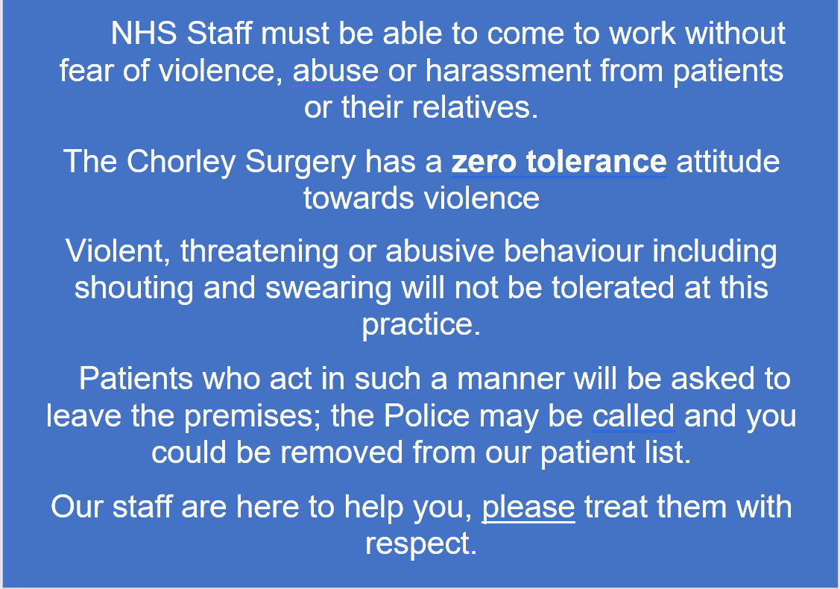

APPENDIX 2 – Action in the event of Panic Button activation.

Refer to the Panic Alarm Procedure Policy No.67

APPENDIX 3 - Do’s and Don’ts when facing angry patients

Do | Don’t
Recognize your own feelings | Meet anger with anger
Use calming body language | Raise your voice, point or stare
Put yourself in their shoes | Appear to lecture them
Be prepared to apologise if necessary | Threaten any intervention unless you are prepared to act on it
Assert yourself appropriately | Make them feel trapped or cornered
Allow people to get things off their chest | Feel that you have to win the argument

Appendix Four

Draft Warning Letter to Patient re: Abusive Behaviour

In Confidence

Dear (insert name)

On your visit to the surgery on ...................., you were .....................................................

We feel we must inform you that this behavior is unacceptable.

It is our responsibility to point out to you that we have a zero-tolerance policy across the NHS for patients who are abusive and/or violent to staff. At the Chorley Surgery we take this policy very seriously and would not hesitate to remove patients from the list who do not abide by our Violence and Aggression policy.

We are happy for you to remain with the practice but insist that you abide by the above-mentioned policy in all your dealings with the practice.

We hope you understand that should such poor behavior occur again; we will have no alternative other than to exercise our right to remove you from our List

Yours sincerely

[Insert title]

Appendix Five

Draft Warning Letter to Career/Relative/Friend of Patient re: Abusive Behaviour

In Confidence

Dear (insert name)

During your visit/telephone/video call to the surgery on...................., you were..............

We feel we must inform you that this behavior is unacceptable.

It is our responsibility to point out to you that we have a zero-tolerance policy across the NHS for careers/relatives/friends of patients who are abusive and/or violent to staff. At The Chorley Surgery we take this policy very seriously.

We are happy for you to continue to contact the surgery in relation to your husband/wife/relative but insist that you abide by the above-mentioned policy in all your dealings with the practice.

We hope you understand that should such poor behavior occur again, we will have no alternative other than to exercise our right to stop any further communication with you in respect to your husband/wife/relative should an incident like this happen again in the future.

Yours sincerely

[Insert title]
Appendix Six

Letter advising of removal from practice list

Dear …………….
I am writing to you following an incident at the practice today whereby you explain what they did here.
While we appreciate that the process may have caused you to feel some upset and anger(alter as needed), we feel the behaviour that was displayed was unacceptable. We have a strict policy on unacceptable behaviour and this will NOT be tolerated.
Our records show that you have previously been warned about such behaviour on previous date when you were explain what they did here. The letter sent on this date explained that repeat instances would result in your removal from the practice register. We have now requested that you are removed from our patient register. This will take place eight days after NHS England receive our request. You will now have to register at an alternative practice.
Kind Regards
Dr
GP Partner
The Chorley Surgery

